FLOPKART

ECOMMERCE WEBSITE

Software Requirements Specification (SRS) Document

For Software Engineering

Version 1.0 approved Date: 06/04/2024

Prepared by

TEAM 9

Aravind G 22BCS011

Dharneesh P S 22BCS022

Hari Prasath R 22BCS033

Jai Ganesh V 22BCS038

Kartheesan D 22BCS044

Table of Contents

Table of Contents ii

1. Introduction 1

1.1 Purpose 1

1.2 Scope 1

1.3 Objective 1

1.4 Hardware Interfaces 1

1.5 Software Interfaces 1

2. Overall Description 2

2.1 Product Functions 2

2.3 Constraints 2

2.4 Functional Requirements 2

# Introduction

Welcome to flopkart, your premier destination for all your online shopping needs. At flopkart, we are committed to providing you with an unparalleled shopping experience that combines convenience, filters, offers, variety, free delivery, and exceptional customer service. With just a few clicks, you can effortlessly add items to your cart and proceed to checkout, making the shopping experience seamless and convenient. Customers will benefit from a user-friendly interface, personalized product recommendations, and secure payment gateways, enhancing their overall shopping experience. Platform administrators will have comprehensive control over user management, content moderation, and platform analytics, facilitating effective oversight and decision-making. With our user-friendly platform, you can explore a vast array of products from the comfort of your own home, whether you are searching for the latest fashion trends, innovative electronics, or everyday essentials. Our dedication to quality ensures that each item in our curated selection meets the highest standards, allowing you to shop with confidence. Join us as we redefine the way you shop online and discover the ease and excitement of flopkart.

The following subsections of the Software Requirements Specifications (SRS) document should provide an overview of the entire SRS.

## Purpose

The purpose of this Software Requirements Specifications (SRS) document is to provide a detailed description of the requirements for the E commerce website. This SRS will allow a complete understanding of what the Website should expect. A clear understanding of the Website and its’ functionality will allow for the correct software to be developed for the end users and will be used for the development of the future stages of the project. This SRS will provide the foundation for the project. Ecommerce websites enable the users to buy the products and allow them to replace or reorder the products. Operating an ecommerce website can be more cost-effective than maintaining a physical store, as it reduces overhead costs associated with rent, utilities, and staff.

## Scope

To promote flopkart, there is a need for a user-friendly conversation for the users on our ecommerce website. The scope of an eCommerce website can vary widely depending on several factors such as the User Authentication, Shopping Cart, Payment Gateway Integration, Search and Filtering. The scope of an eCommerce website is essential to carefully plan and update the features based on the target audience.

## Objective

To develop a high performing, flexible and user-friendly ecommerce website and make the users explore and shop their requirements from their home.

## Hardware Interfaces

Hosting Server Configuration (Minimum System Requirements):

|  |  |
| --- | --- |
| Specifications | Particulars |
| OS | Windows 2012 R2 32/64-Bit |
| CPU | Intel Core i3 & above - 4 cores |
| RAM | 8 GB |
| Storage | 512 GB/1 TB Hard Drives |
| Bandwidth | 4-8 MBPS |

## Software Interfaces

1) Frontend

* HTML
* CSS

2) Backend

* Python

3) Database

* SQL Lite3 (Django)

These Frontend, Backend and database are integrated using Django Framework

# Overall Description

## Product Functions

|  |  |
| --- | --- |
| S.No. | Particulars |
| 1 | User Registration |
| 2 | User Profile |
| 3 | User Login |
| 4 | User Logout |
| 5 | Website Home Page |
| 6 | Product Page |
| 7 | Cart |
| 8 | Product Search |
| 9 | Filters |
| 10 | Admin Page |

## Constraints

Constraints for an eCommerce website can vary depending on several factors

* Limited budget can restrict the investment in website development, hosting, marketing, and other essential components.
* Tight deadlines for launching the eCommerce website can limit the time available for development, testing, and optimization.
* Inadequate user experience design can result in usability issues, and low conversion rates. Limited resources may restrict the implementation of user-friendly features.

## Functional Requirements

|  |  |  |  |
| --- | --- | --- | --- |
| S. No. | Features | Functionality | Descriptions (Including Sub-Functionality) |
| 1 | User Registration | GUI shall be required for user registration on the website/web software. | When the user opens the URL of website, GUI should popup for registration.  GUI will include the basic information about the user such as: E-mail ID/Contact number, Password.  All information related to the user, which he/she has entered the GUI, should be stored into the relational database. |
| 2 | User Profile | GUI shall be required to display the user profile after log-in. | When user will login into the website, there should be a tool to open account settings for the user.  Users should be able to change the profile features like password, contact number, mail id, etc.  All the modified features should be updated into the database. |
| 3 | User Login | GUI shall be required to login onto the website. | When the user opens the URL of website, GUI should popup for Log-in.  There should be options like User-ID and Password to login onto the website.  If a user enters incorrect information, it should give an alert or popup for wrong input.  After successful log-in user should redirect to the home page. |
| 4 | User Logout | To log out from the website. | Only if user is login onto the website, then logout tool/button should be visible otherwise it shall be void. |
| 5 | Website Home Page | Home Page shall be required for website. | Home page contains various product cards including their minimal details  It also contains search and filter options for user experience |
| 6 | Product Page | Product Page for displaying the product details. | The product Page contains the actual details of the product including images, ratings, and further facilities. |
| 7 | Cart | Cart Page for bookmarking products which customers can decide on later. | Cart Page can have functionalities to add or remove items and to initiate orders. |
| 8 | Product Search | To search specific products based on their name/ product id. | Search bar resides on the home page to help customers to search specific products. |
| 9 | Filters | Filter out products of categories. | People will be able to filter products based on different constraints  <example: price, ratings, tags> |
| 10 | Admin Page | Page only for admins to make changes on the site. | Page for admin to organize the application like updating product details and for database management. |

**UML USECASE DIAGRAMS**

COMPLETE USECASE DIAGRAM

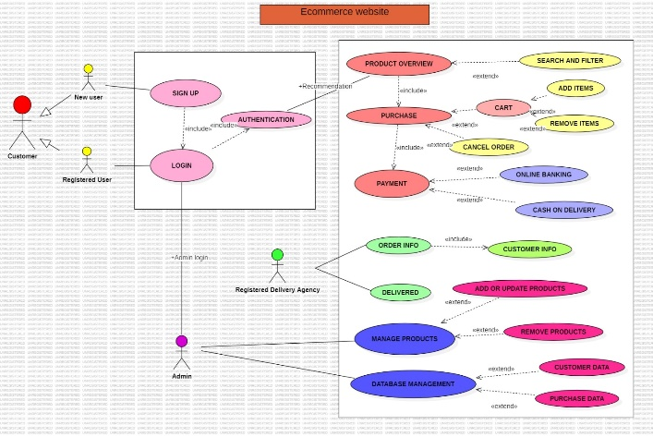

ADMIN USECASE DIAGRAM

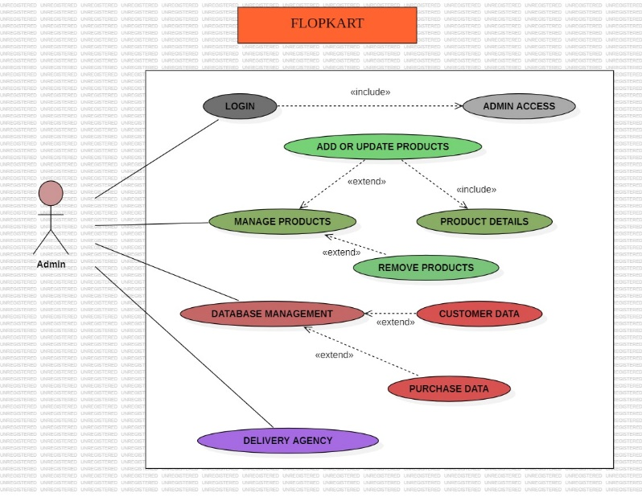

USER USECASE DIAGRAM

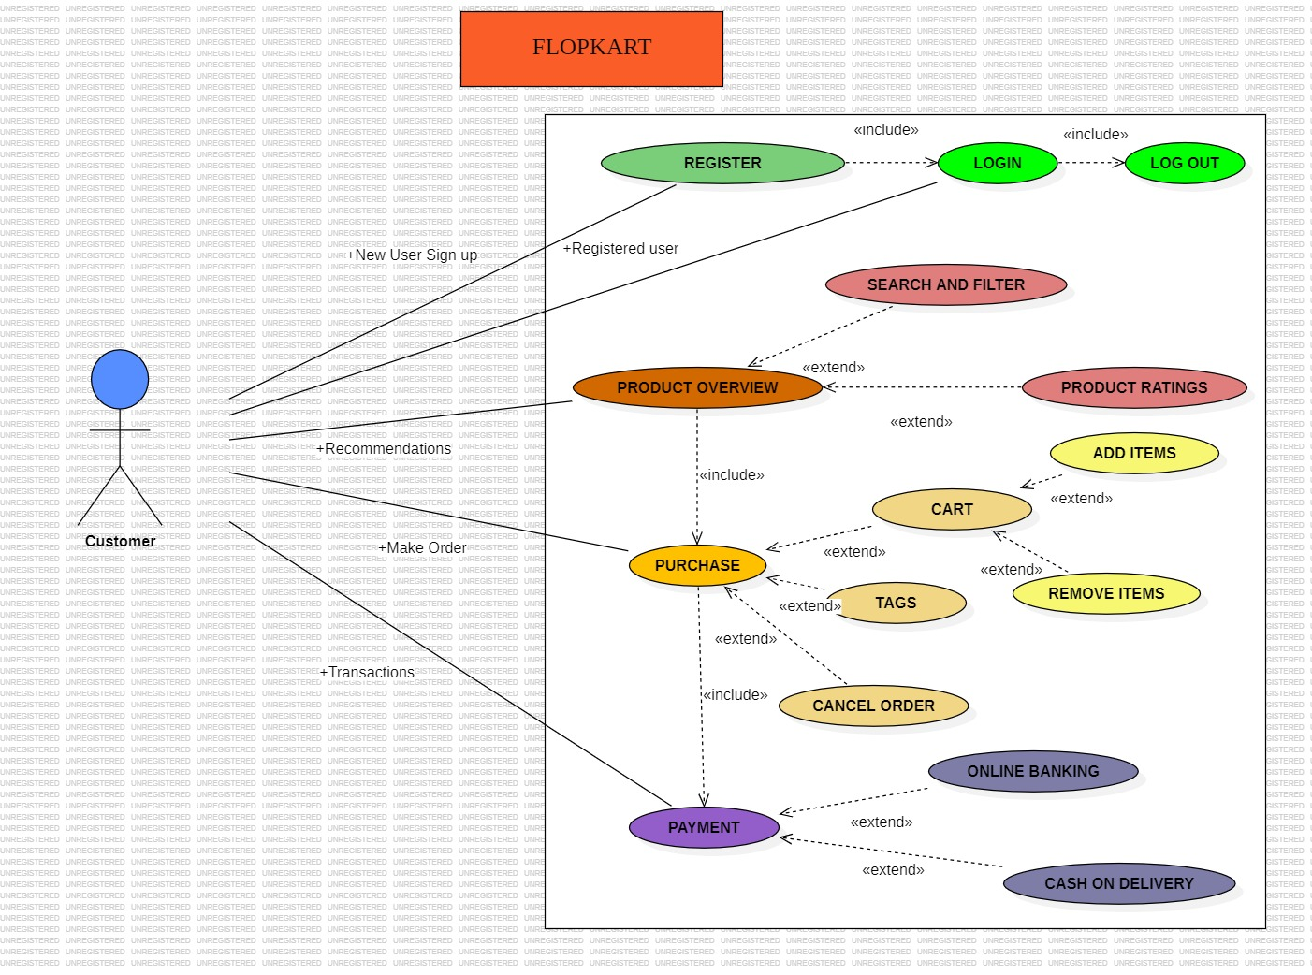

DELIVERY AGENCY USECASE DIAGRAM

